|  |
| --- |
| ALASKA STATE PARKS STATEWIDE CONCRETE TOILET INSTALLATIONProject No. 71882-3Bidder Registration Form |

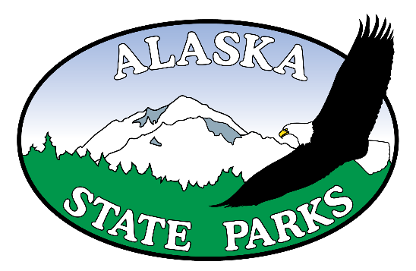

|  |  |
| --- | --- |
| Company Name: |  |
| Contact Name: |  |
| Mailing Address: |  |
|  |  |
| E-mail Address: |  |
| Phone Number: |  |
| Fax Number: |  |

Are you registering as a: ( ) General ( ) Subcontractor ( ) Supplier or ( ) Plan center

Please send to: Alaska State Parks, Design and Construction

Fax: 907-269-8917

E-mail: [katie.winter@alaska.gov](mailto:katie.winter@alaska.gov)

For questions call: 907-269-8731