Mosquito Lake SRS Sanitary Improvements

Project No. 71007-2

Bidder Registration Form
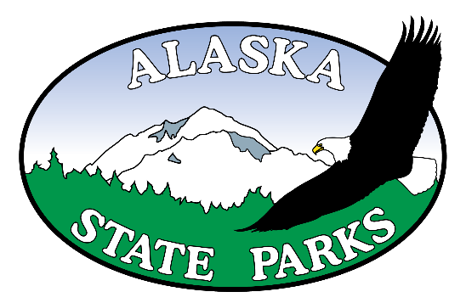

Company Name:

Contact Name:

Mailing Address:

E-mail Address:

Phone Number:

Fax Number:

Are you registering as a: ( ) General ( ) Subcontractor ( ) Supplier or ( ) Plan center

Please send to: Alaska State Parks, Design and Construction
Fax: 907-269-8917
E-mail: rangell.soriano@alaska.gov
For questions call: 907-269-8937

