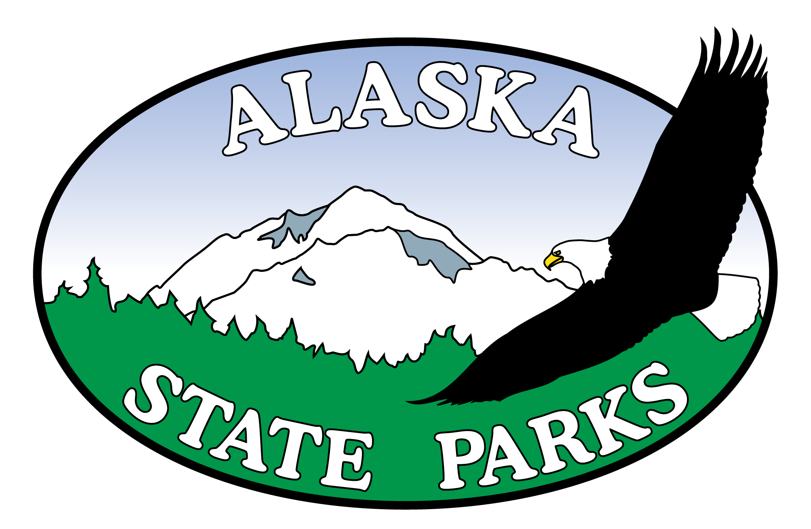

KRSMA Kenai River Flats Facility Improvements

Project No. TA-21002/CFHWY00688

Bidder Registration Form

Company Name:

Contact Name:

Mailing Address:

E-mail Address:

Phone Number:

Fax Number:

Are you registering as a: ( ) General ( ) Subcontractor ( ) Planholder or ( ) Supplier

Please send to: Alaska State Parks, Design and Construction
Fax: 907-269-8907
E-mail: rangell.soriano@alaska.gov
For questions call: 907-269-8736

