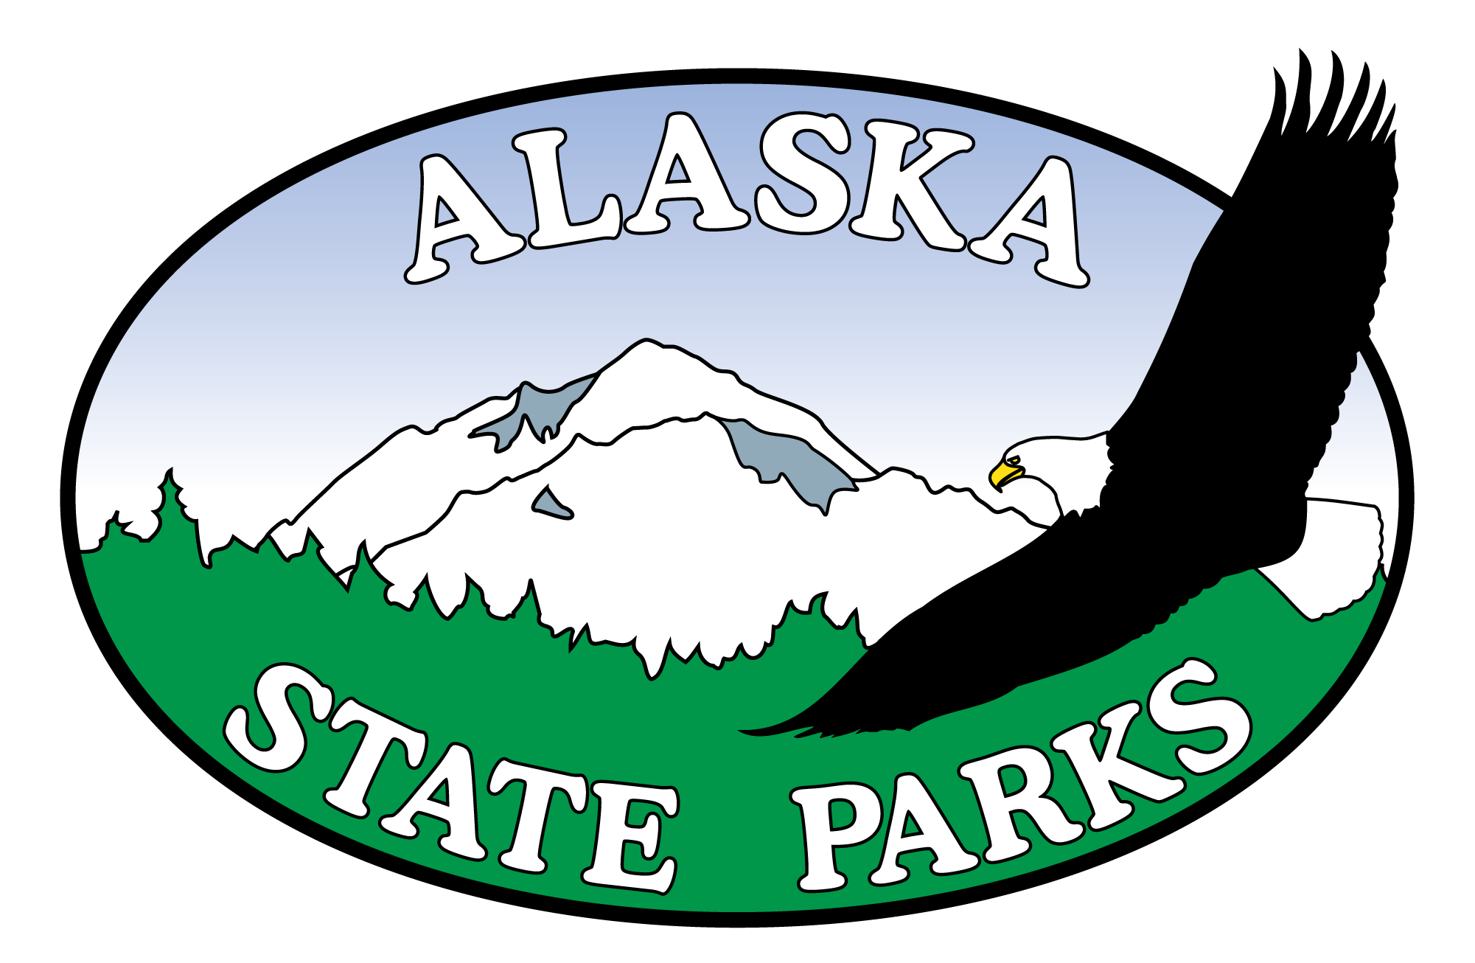

Coal Creek to Center Pit Road Restoration

Project No. 52959-7

Bidder Registration Form

Company Name:

Contact Name:

Mailing Address:

E-mail Address:

Phone Number:

Fax Number:

Are you registering as a: ( ) General ( ) Subcontractor or ( ) Supplier

Please send to: Alaska State Parks, Design and Construction
Fax: 907-269-8907
E-mail: katie.winter@alaska.gov
For questions call: 907-269-8731

