

For Immediate Release: March 30, 2021

**Public meeting planned on trails to link Tanana Valley forest roads**

**(Fairbanks, AK)** – The Division of Forestry and the Interior Alaska Trails and Parks Foundation will hold a virtual public meeting Thursday, April 1, from 6 p.m. to 7:30 p.m. on proposed construction of trails connecting forestry roads in the Tanana Valley State Forest, funded by a state parks grant.

The proposal is for construction of four miles of all-season, multiple-use trails to link 35 miles of forestry roads in the Rosie Creek area with more than 18 miles of forestry roads in the Zasada and Bonanza Creek Road networks to the west. The construction would run from July 15 through September 30, 2022.

Interior Alaska Trails and Parks Foundation, in cooperation with the Division of Forestry, is applying for a $300,000 grant from the Division of Parks and Outdoor Recreation to fund the trail construction work through its Alaska Recreational Trails Program (RTP). The parks division administers the federally funded matching grants to develop and repair motorized and non-motorized recreational trails, and for trail-related environmental protection, safety and educational projects.

The trails would expand opportunities for both motorized and non-motorized trail users in the area, and will complement recreational improvements to the Rosie Creek roads expected to be done this summer.

The project would also provide important recreational improvements like directional signs, map kiosks, and GPS map links along the way. If approved by researchers with the U.S. Forest Service and University of Alaska Fairbanks, the project could also include interpretive materials about the Bonanza Creek Experimental Forest, through which the trail connectors would pass.

The project offers the opportunity to link a working state forest with a well-signed and well-maintained recreational trail. Area forest roads are already used as trails by bikers, all-terrain vehicle users, skiers, hunters, snowmachiners, dogsledders, runners and others. The trail connections, along with directional signs and information, will expand recreational opportunities for residents and visitors, while still providing for forestry research and harvest in the Tanana Valley State Forest.

Members of the public interested in commenting on the proposed project and the grant may attend the virtual public meeting on Thursday, from 6-7:30 p.m. via the online meeting program Zoom, at:

<https://zoom.us/j/95051377495?pwd=dnlsRWs3L1FZSWc3TFRjMEVlMW1UQT09>

**Zoom** **Meeting ID**: 950 5137 7495

**Passcode**: forestry

Those unable to attend the meeting may submit comments and questions about the proposed project to Geoff Orth (gcorth@straydogs.us) with Interior Alaska Trails and Parks Foundation no later than 5 p.m. on April 28, 2021.

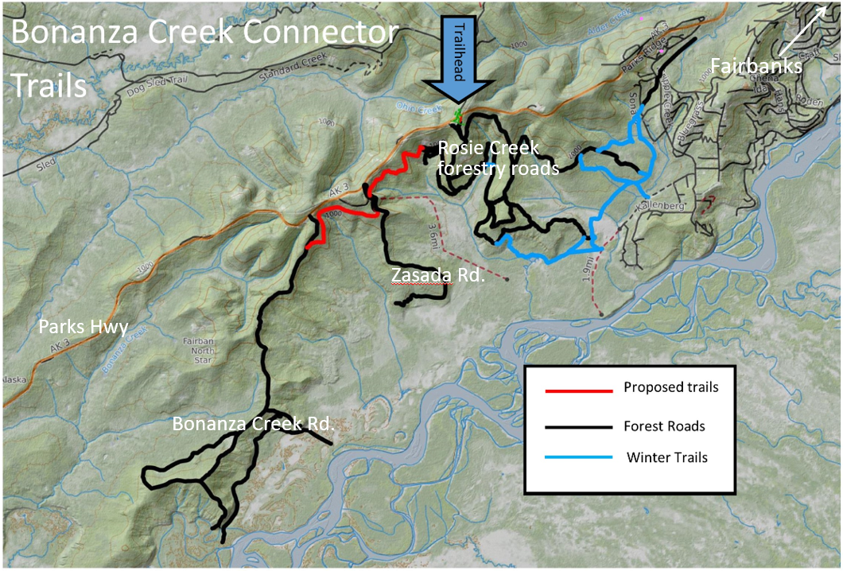

*The Alaska Recreational Trails Program is the possible funding agency for a proposal to build four miles of trail to connect forest roads in the Bonanza Creek Road area with those in the Rosie Creek areas. For more information, visit: http://dnr.alaska.gov/parks/grants/trails.htm*

**CONTACT:** Alison Arians, (907) 748-3712, [alison.arians@alaska.gov](mailto:alison.arians@alaska.gov)

###