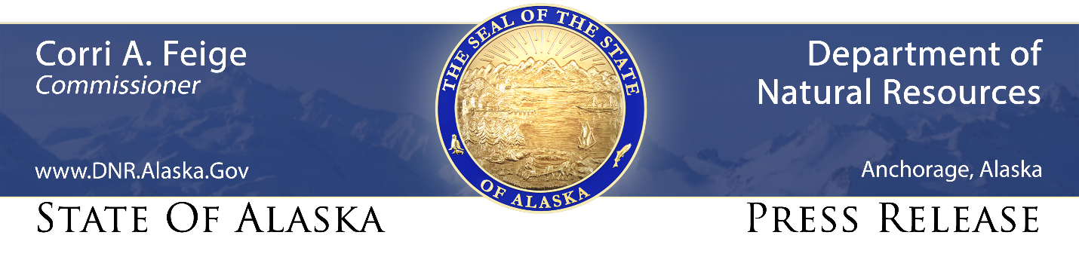

For Immediate Release: May 5, 2021

New DNR online maps are next step in Unlocking Alaska Initiative

(Anchorage, AK) – The Department of Natural Resources (DNR) today took the next step in advancing Governor Mike Dunleavy’s “Unlocking Alaska” initiative, publishing online maps showing navigable waters and state-owned submerged lands, including those in the Tongass National Forest and National Park Service lands in Alaska.

The maps and associated information are important elements in the governor’s initiative, announced in March, asserting state management authority over navigable waters and the submerged lands beneath them, said DNR Commissioner Corri Feige.

“After decades of federal foot-dragging in acknowledging the state’s ownership and authority over these resources, Alaskans can now go to a single website to clearly see the navigable waters that we received control of at statehood, and which they have legal rights to access according to state rules and regulations,” Feige said.

Under the U.S. Constitution and federal law, and as reinforced by two unanimous U.S. Supreme Court decisions, Alaskans may travel on navigable waters across state-owned submerged lands rivers and lakes subject to state regulations and permitting requirements, rather than federal requirements.

The website - https://dnr.alaska.gov/mlw/paad/nav/ - offers a wealth of information relating to the governor’s initiative and navigable waters issues, including links to maps showing the expansion of state-controlled waters inside conservation units created by the Alaska National Interest Lands Conservation Act of 1980 (ANILCA); links to the Alaska Mapper online tool that displays details on navigable waters statewide; and links to a variety of supplementary information.

The website also offers a form that boaters can use to share trip information with DNR -- such as put-in and take-out locations, water conditions, cargo loads, and photographs – that can help the state defend against federal usurpation of state authority over submerged lands.

“We will soon publish additional data and documents showing the extent of state-owned and controlled resources in other federal areas, and we look forward to engaging with Alaskans about these updated maps,” said Jim Walker, head of DNR’s Public Access Assertion and Defense (PAAD) unit, which is responsible for advancing Alaska’s interests in securing rightful access to public land in the state.

Walker encouraged members of the public to contact the PAAD unit to report on any interactions they might have with federal authorities on state-owned submerged lands and state-managed navigable waters.

CONTACT: Dan Saddler, 907-269-8427, dan.saddler@alaska.gov

###

STAY CONNECTED:
DNR Newsroom: http://dnr.alaska.gov/commis/dnr_newsroom.htm
DNR on Social Media: http://dnr.alaska.gov/commis/social_media.htm
DNR Public Information Center: http://dnr.alaska.gov/commis/pic/

