For Immediate Release: May 10, 2021

Mat-Su Forestry to conduct prescribed burns in Wasilla and Butte

(Palmer, AK) – Wildland firefighters from the Division of Forestry’s Mat-Su area station plan to reduce fire danger in Wasilla and Butte by taking advantage of favorable weather conditions to conduct two prescribed burns to remove dry grass and other vegetation over the next few days or weeks.

A 15-acre prescribed burn on private land in the Sitze Road area north of Wasilla began today and will conclude Tuesday, if conditions allow. The burn is a cooperative effort between the landowner, the forestry division and fire departments in the Matanuska Susitna Borough.

The Mat-Su area forestry station’s initial attack helicopter will be pre-positioned in the area to support the operation with water drops, if needed. In addition to reducing wildfire danger in the area by removing dry fuels, the burn will provide a good training exercise for personnel from the Central Mat-Su and West Lakes fire departments in working alongside experienced Mat-Su Area wildland firefighters.

On Wednesday, Mat-Su Area wildland fire crews plan to work with firefighters from the Butte Volunteer Fire Department to conduct a prescribed burn on a half-acre of state-managed lands at the Kenny and Patti Barber Shooting Range off Maud Road, in the Knik River Public Use Area.

Wednesday’s burning of grass on the range’s small-arms range will complete work begun on Saturday, when the Palmer-based Gannett Glacier Type 2 Initial Attack Crew responded to a human-caused, shooting-related wildfire at the range.

While the range is closed to the public on Wednesdays, area residents and visitors may see smoke from these prescribed operations. In addition to reducing wildfire danger in both areas, the prescribed burns should facilitate the growth of some bright, green grass once greenup hits.

CONTACT: Cal Maki, assistant fire management officer Mat-Su Area Forestry, 907-761-6340, caley.maki@alaska.gov.

###

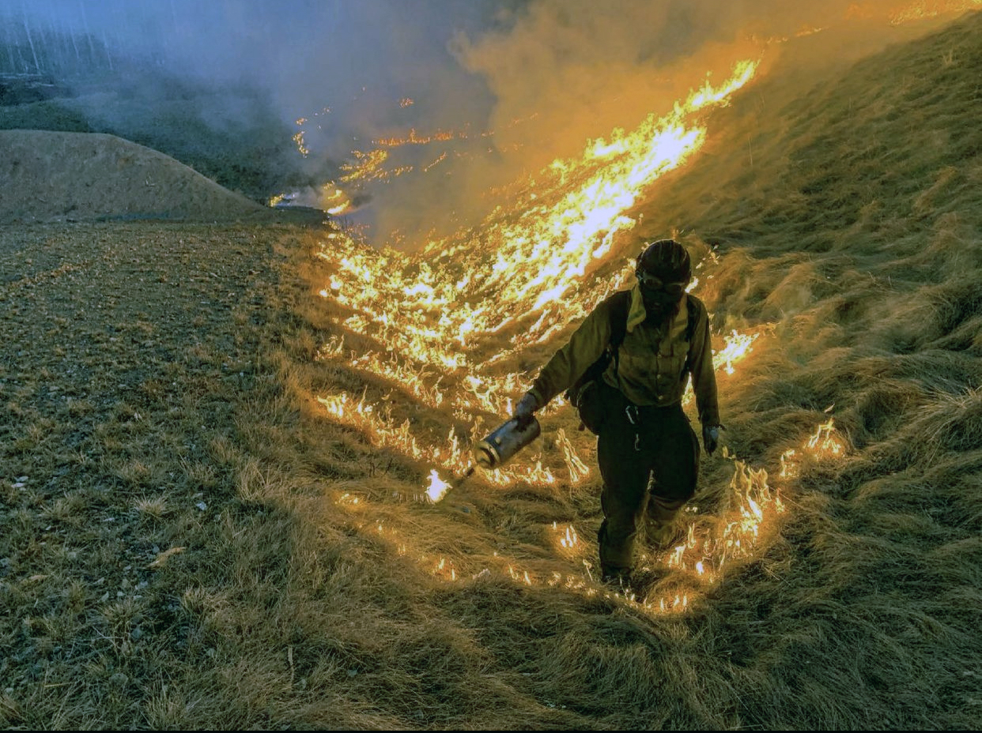
A member of the Gannett Glacier Type 2 Initial Attack Crew uses a drip torch to burn dry grass as part of a burn operation during suppression of the Maud Road Fire on Saturday night at the Kenny and Patti Barber Shooting Range in the Knik Public Use Area. Weather permitting, the crew will return on Wednesday to finish a planned prescribed burn by burning grass off the small arms range at the shooting range. (Photo courtesy Gannett Glacier Fire Crew).

