Alaska Interagency News Release | 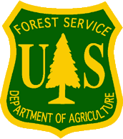  Alaska Department of Natural Resources /  U.S. Forest Service

FOR IMMEDIATE RELEASE
April 30, 2021

Warmer weather means spruce beetles will soon be taking flight

(Anchorage, AK) – Southcentral Alaska continues to see impacts from an ongoing spruce beetle outbreak that has affected more than 1.1 million acres across the region. While the outbreak has subsided in some areas, many areas continue to experience steady or increasing beetle activity.

Native to Alaska’s forests, spruce beetles feed and reproduce in spruce trees. All native spruce species and most ornamental species of spruce are suitable hosts for spruce beetle.

“Spruce beetles become active with warmer spring temperatures. Adult beetles typically start to emerge from their host trees once temperatures reach around 60 degrees,” said Jessie Moan, Entomologist with the U.S. Forest Service.

Adult beetles emerge from their host trees to seek out and attack new trees during their flight period, which typically occurs from May to July. Forest health professionals recommend that landowners avoid cutting live spruce trees during this period. If spruce trees need to be removed during the flight period, the trees should be processed as quickly as possible.

“Once the beetles start their flight period, it’s important for landowners to keep an eye on their spruce trees for signs of infestation. Even spruce trees that look green and healthy should be regularly checked during this time,” Moan said.

Some signs of infestation include reddish-brown boring dust at the base of a tree and in bark cracks, and reddish- or yellowish-brown pitch masses on the tree trunk indicating attack sites.

For trees showing signs of spruce beetle infestation, property owners should consider taking steps in the fall and winter that will disrupt the beetles’ ability to complete their life cycle and emerge to infest nearby trees, such as removing the infested trees and processing them before the following spring.

For Alaska-specific spruce beetle information, including management tactics, signs and symptoms of spruce beetle attacks, beetle biology, and more, visit www.alaskasprucebeetle.org. Additional information is available from U.S. Forest Service, Forest Health Protection at https://www.fs.fed.us/foresthealth/ or the Alaska Division of Forestry, Forest Health Program at http://forestry.alaska.gov/insects/index.

CONTACTS:
Jason Moan, Alaska Division of Forestry, (907) 269-8460, jason.moan@alaska.gov
Tim Mowry, Alaska Division of Forestry, (907) 356-5512, tim.mowry@alaska.gov
Jessie Moan, U.S. Forest Service, (907) 743-9453, mary.moan@usda.gov
Michelle Putz, U.S. Forest Service, (907) 747-2708, michelle.putz@usda.gov

###

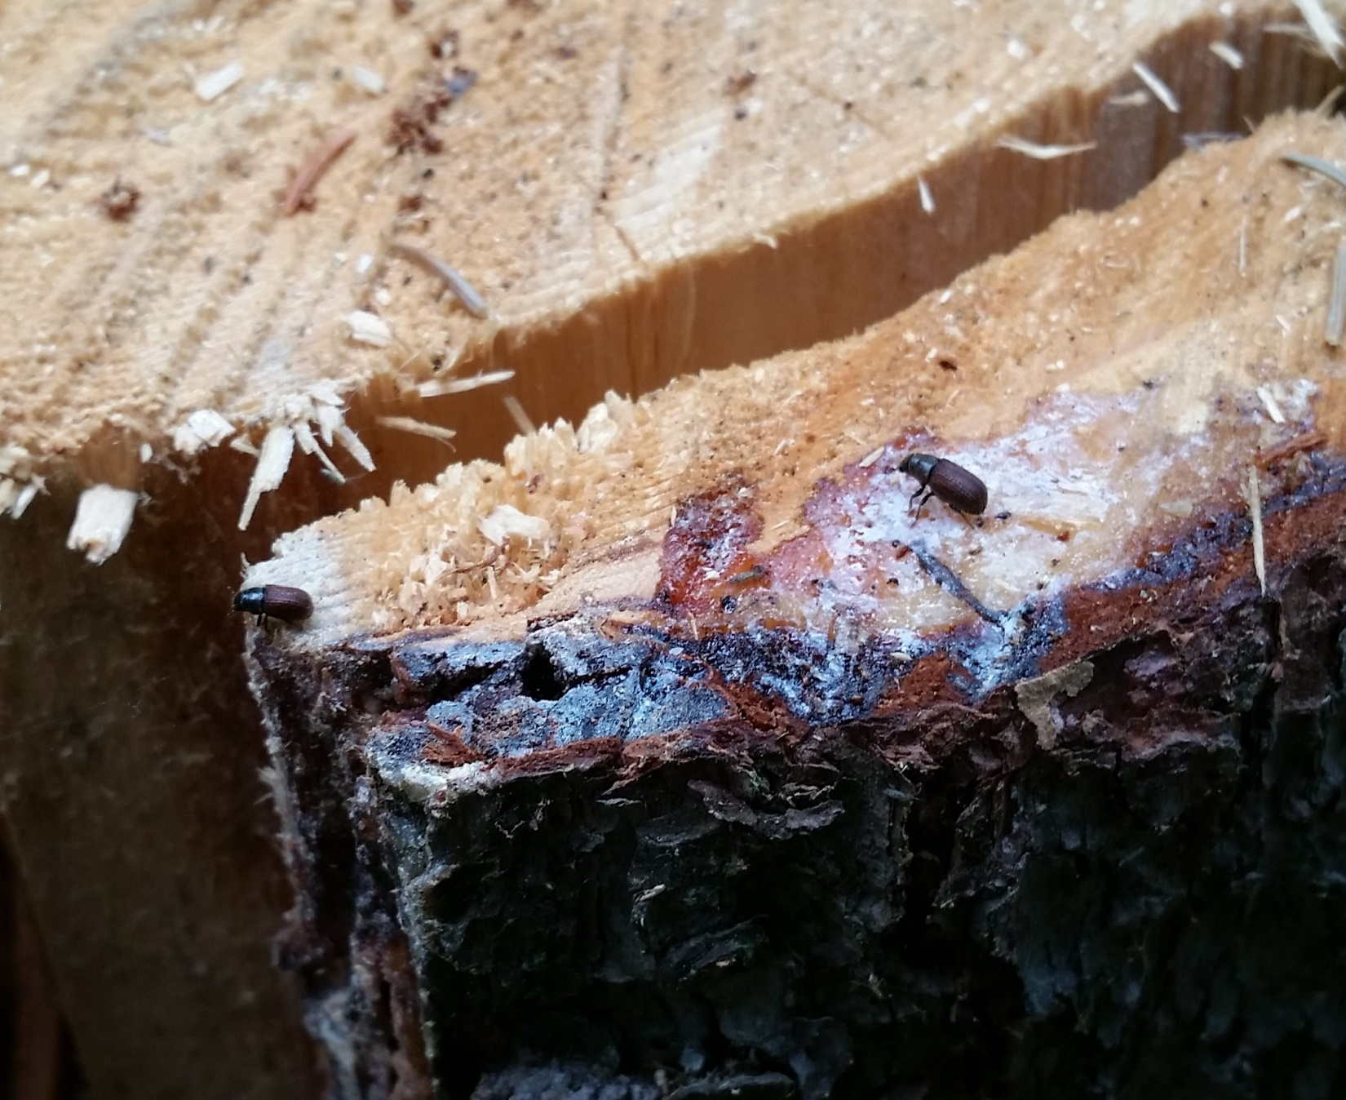
Two adult spruce beetles are shown after having landed on a freshly cut spruce stump. During their adult flight period, spruce beetles are highly attracted to freshly cut or freshly fallen spruce trees. Landowners are advised to avoid cutting live trees during the beetle flight period. (Courtesy of Alaska Division of Forestry)

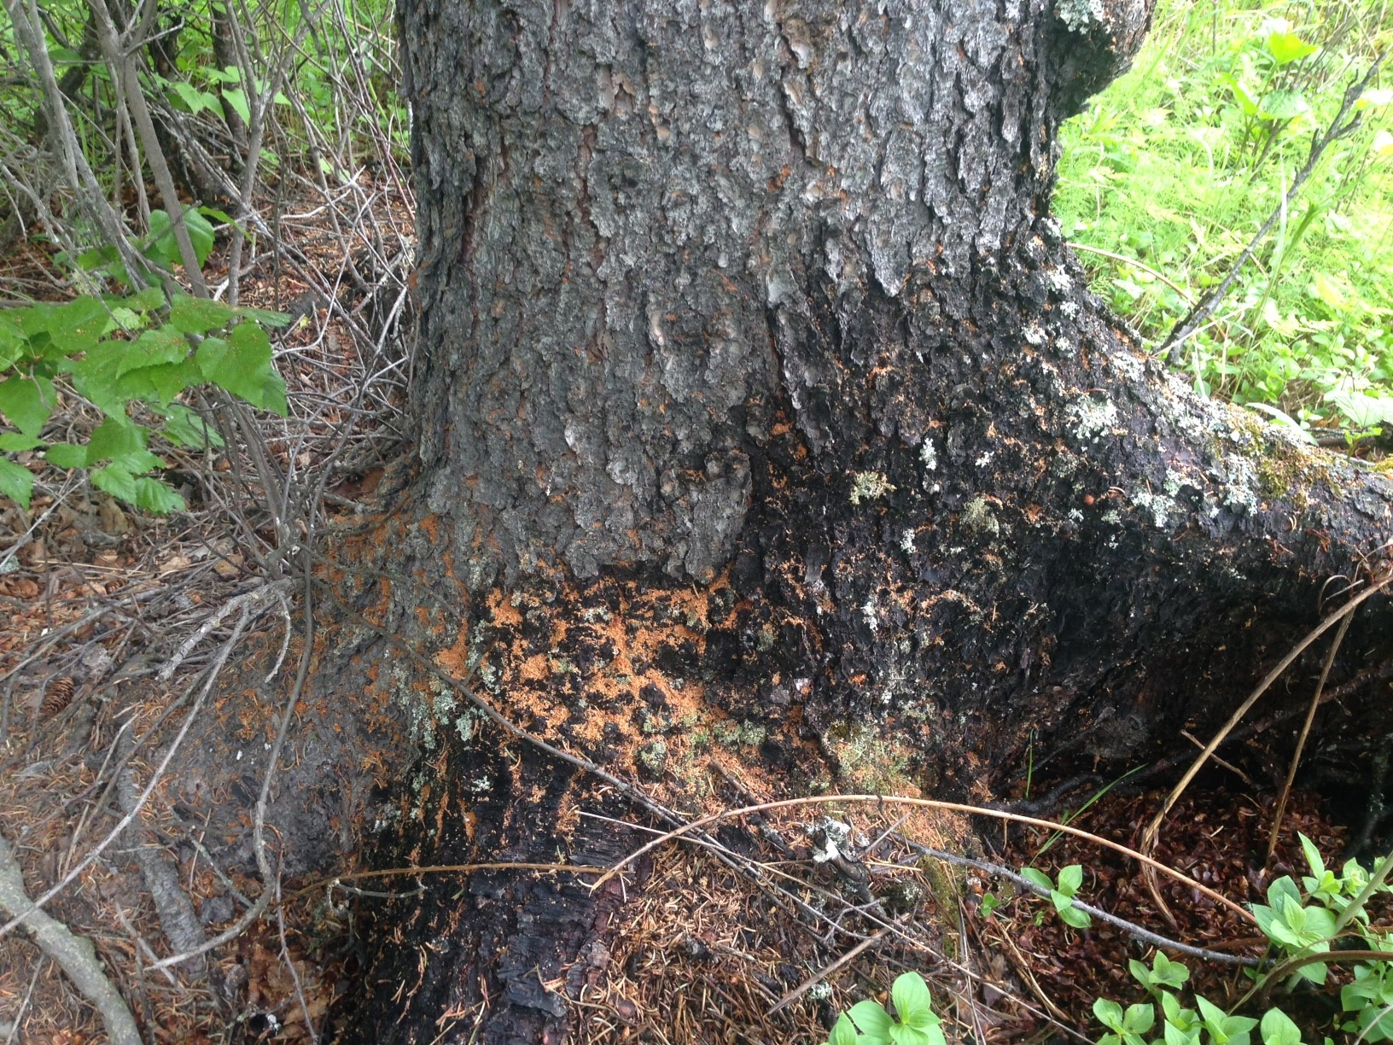
Adult spruce beetles will soon emerge from their host trees to seek out and attack new trees. The presence of boring dust around the base of the tree, like that shown here, is commonly associated with spruce beetle attacks. (Courtesy of Alaska Division of Forestry)

