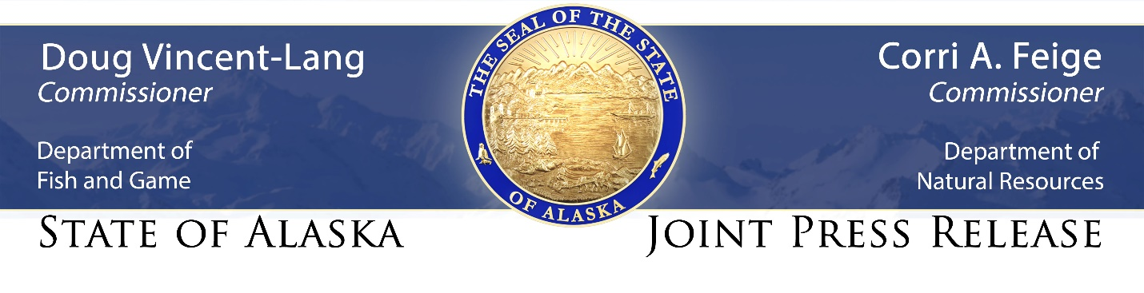
For Immediate Release: April 28, 2021

State forestry to conduct prescribed burns at Creamer’s Field

(Fairbanks, AK) – Weather permitting, the Alaska Division of Forestry will be partnering with the Department of Fish and Game to conduct multiple prescribed burns at Creamer’s Field Migratory Waterfowl Refuge starting as early as Monday, May 3.

The burns will be ignited on four separate fields totaling approximately 40 acres on the 2,400-acre refuge on College Road (see attached map). Burning the dried grass that makes up most of the fuel now will enhance habitat for waterfowl and other wildlife that live on or visit the refuge, while also reducing the potential for wildfires later this summer when conditions are drier.

“These prescribed burns are invaluable for the ecosystem,” said Ryan Klimstra, a wildlife biologist with the Alaska Department of Fish and Game in Fairbanks. “Using fire as a management tool directly enhances soil quality and promotes native plant diversity while aiding in invasive weed elimination. Post-fire habitat conditions will benefit many species, ranging from microorganisms and insects all the way up to waterfowl and moose.”

Smoke from the fires will likely be visible throughout Fairbanks during the burns, but efforts will be made to minimize smoke impacts to the public.

The prescribed burns also provide valuable, hands-on training for the division’s wildland firefighters as they prepare for the upcoming wildland fire season. It takes about 12 people to light and monitor the fires, and fire managers expect the project to take one or two operational periods to complete.

“Any chance we can get to put fire on the ground in a controlled environment helps us train our firefighters, both in terms of understanding fire behavior and conducting a controlled burn,” said Acting Fairbanks Area Fire Management Officer Gordon Amundson. “These burns give our firefighters a chance to practice what they’ve been learning and reviewing in the classroom, as well as get their hands dirty with some real, live fire.”

The Department of Fish and Game manages the Creamer’s Field refuge to provide habitat for migratory waterfowl and for compatible public uses, including wildlife viewing, research, nature education and other forms of non-motorized recreation.

The refuge will remain open during the prescribed burns, but specific areas may be closed for firefighter and public safety. Signs will be posted at trailheads to alert visitors of any closed areas.

Fire managers have completed a burn plan that has been approved by the state departments of Fish and Game, and Environmental Conservation. The forestry division has set a burn window of May 3 to May 21 to complete the burns. The exact date of the burns will depend on the weather.

Firefighters will not start the burn if the temperature, wind speed and direction, relative humidity and other conditions exceed parameters laid out in the burn plan. A test burn will be conducted to make sure conditions are favorable on the scheduled burn day.

CONTACT: Ryan Klimstra, Department of Fish and Game wildlife biologist, (907) 459-7223, ryan.klimstra@alaska.gov or Tim Mowry, Division of Forestry public information officer, (907) 356-5512, tim.mowry@alsaka.gov.

###

