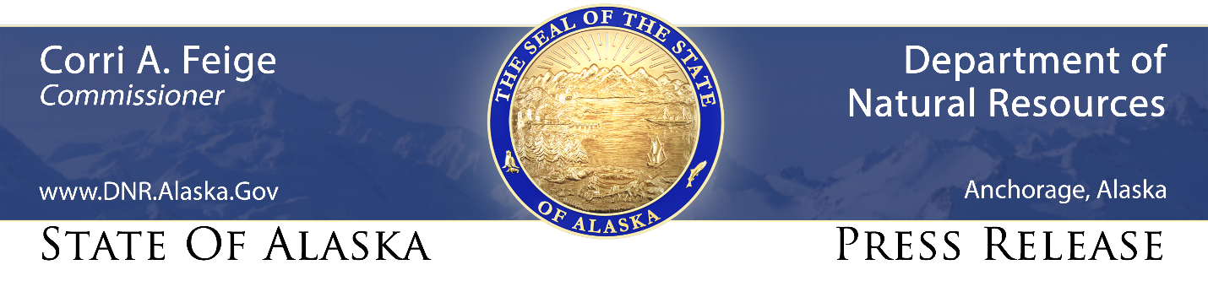
For Immediate Release: April 16, 2021

Alaska Assistant AG Anne Nelson wins national Smokey Bear Award

(Anchorage, AK) – The Alaska Department of Law (DOL) and Alaska Division of Forestry (DOF) are happy to announce that Chief Assistant Attorney General Anne Nelson has been awarded a 2021 national bronze Smokey Bear Award for her work in updating Alaska’s wildland fire statutes and regulations.

The Smokey Bear Awards are reserved for individuals, teams, and organizations that provide outstanding service with significant and sustained program impact in the wildfire prevention arena. Nelson was one of five individuals across the country who received a 2021 Smokey Bear Award. The program is managed by the National Association of State Foresters (NASF), the Ad Council, and the USDA Forest Service.

Nelson played a key role in the passage of House Bill 355 by the Alaska Legislature in 2018, which revamped the Alaska Wildland Fire Protection Statutes and Regulations originally adopted in 1961. In addition to drafting and ushering the bill through the legislative process, Nelson was instrumental in drafting regulations implementing the new law and its prevention and enforcement authorities. The regulations were the springboard for the Division of Forestry’s public education campaign — “Take Time to LEARN Before You Burn” — and the launch of its new mascot, Spruce the Moose, who will work alongside Smokey Bear to prevent human-caused wildfires through education and outreach.

“Anne’s hard work over the past several years championing the state’s new wildland fire statutes and regulations has helped lead the Division of Forestry’s wildland fire prevention program into a new era and will have a tremendous impact on reducing the number of human-caused wildland fires in Alaska,” Division of Forestry Fire & Aviation Chief Norm McDonald said. “Her diligence and attention to detail during the legislative process have really set us up for a successful program.”

Nelson was surprised to hear she had won a Smokey Bear Award and said it was a team effort. The bottom line, she said, is the safety of Alaskans and Alaska’s wildland firefighters.

“I’m honored to be recognized with a Smokey Bear Award, but the real reward is knowing that the dedicated professionals in the Alaska Division of Forestry’s wildland fire prevention program have legal support and resources to educate the public, prevent fires from starting, and when appropriate, initiate enforcement action,” Nelson said. “The program helps protect Alaskans — including its wildland firefighters — from the devastating effects of wildland fire.”

The new Alaska Wildland Fire Protection Statutes and Regulations restructured the compliance and enforcement aspects of the DOF wildland fire prevention program to include options and prevention tools such as fines for non-criminal minor offenses. The original laws only afforded the issuing of a criminal citation for all burning violations. The successful passage of the new law and regulations initiated a new programmatic approach that focuses on education and enforcement when needed, McDonald said.

Nelson also played an integral role in assisting DOF prevention staff with drafting new regulations to implement the new law, including a review by the Alaska Supreme Court of the bail schedule for the new non-criminal offenses established as part of the law.

“Anne has been a dedicated member of the Department of Law Natural Resources team and is now heading up the entire section. It is nice to see her gain the recognition she rightly deserves,” said Deputy Attorney General Cori Mills.

The 2021 Smokey Bear Awards will be presented at the 2021 NASF Annual Meeting in Pittsburgh, Pennsylvania, on September 9, 2021. To view the press release from NASF announcing the award winners, go to https://www.stateforesters.org/newsroom/smokeybear-awardees-chosen-for-their-ingenuity-exceptional-dedication-to-wildfire-prevention/

CONTACT: Tim Mowry, Alaska Division of Forestry public information officer, (907) 356-5512, tim.mowry@alaska.gov

