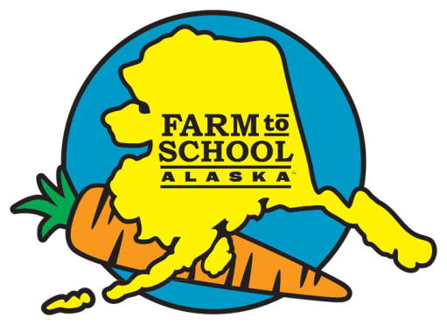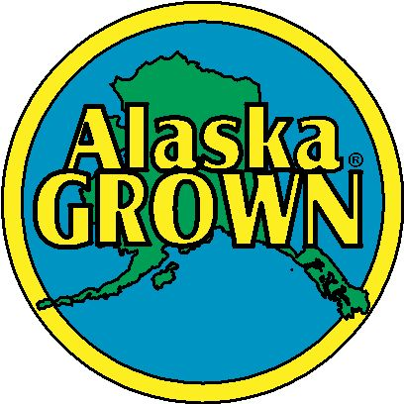

* An amazing fact about the company
* An amazing fact about the health benefits of the produced food
* An interesting bit of information for the produced food ‘Alaska style’ (something like that, like Alaska temperatures make the food sweeter)
* An interesting fact about the family history of the company
* Information about how to use the food produced
* How big is the operation?

“Add a quote from the producer here.”

*Name of producer*

Add a picture of the producer here.

Make your background picture a large picture of what they farm. (Ex: A close-up shot of broccoli.)